CSE321 Project 2

# Purpose

Design a countdown alarm system that can be controlled by a user to set the countdown time, start and stop the timer, and be alerted of the remaining time by the LCD display.

# Inputs

* 4x4 Matrix Keypad:
  + Buttons for Numbers 0-9, A, B, and D

# Outputs

* LCD output display
* LEDs (4)

# Relationships

* Any time any keypad input is detected, a single LED will light up until the key is released.
* Numbers 0-9 are used to set the timer duration when the timer is set to input mode. During input mode, the LCD outputs a prompt to set the timer duration and displays the duration that has so far been entered. The maximum duration that can be input is 9 minutes and 59 seconds.
* Button A switches the timer to countdown mode. During countdown mode, the remaining time goes down by one second per second from the input timer duration down to 0. The remaining time is displayed on the LCD in this mode as “Time Remaining: **m:ss**”.
* Button B
  + clears the remaining time if the timer is currently counting down
  + exits out of the alarm mode if the timer has counted down to zero
* When the countdown timer reaches zero, the timer switches to the alarm mode in which multiple LEDs will be on.

# Plan

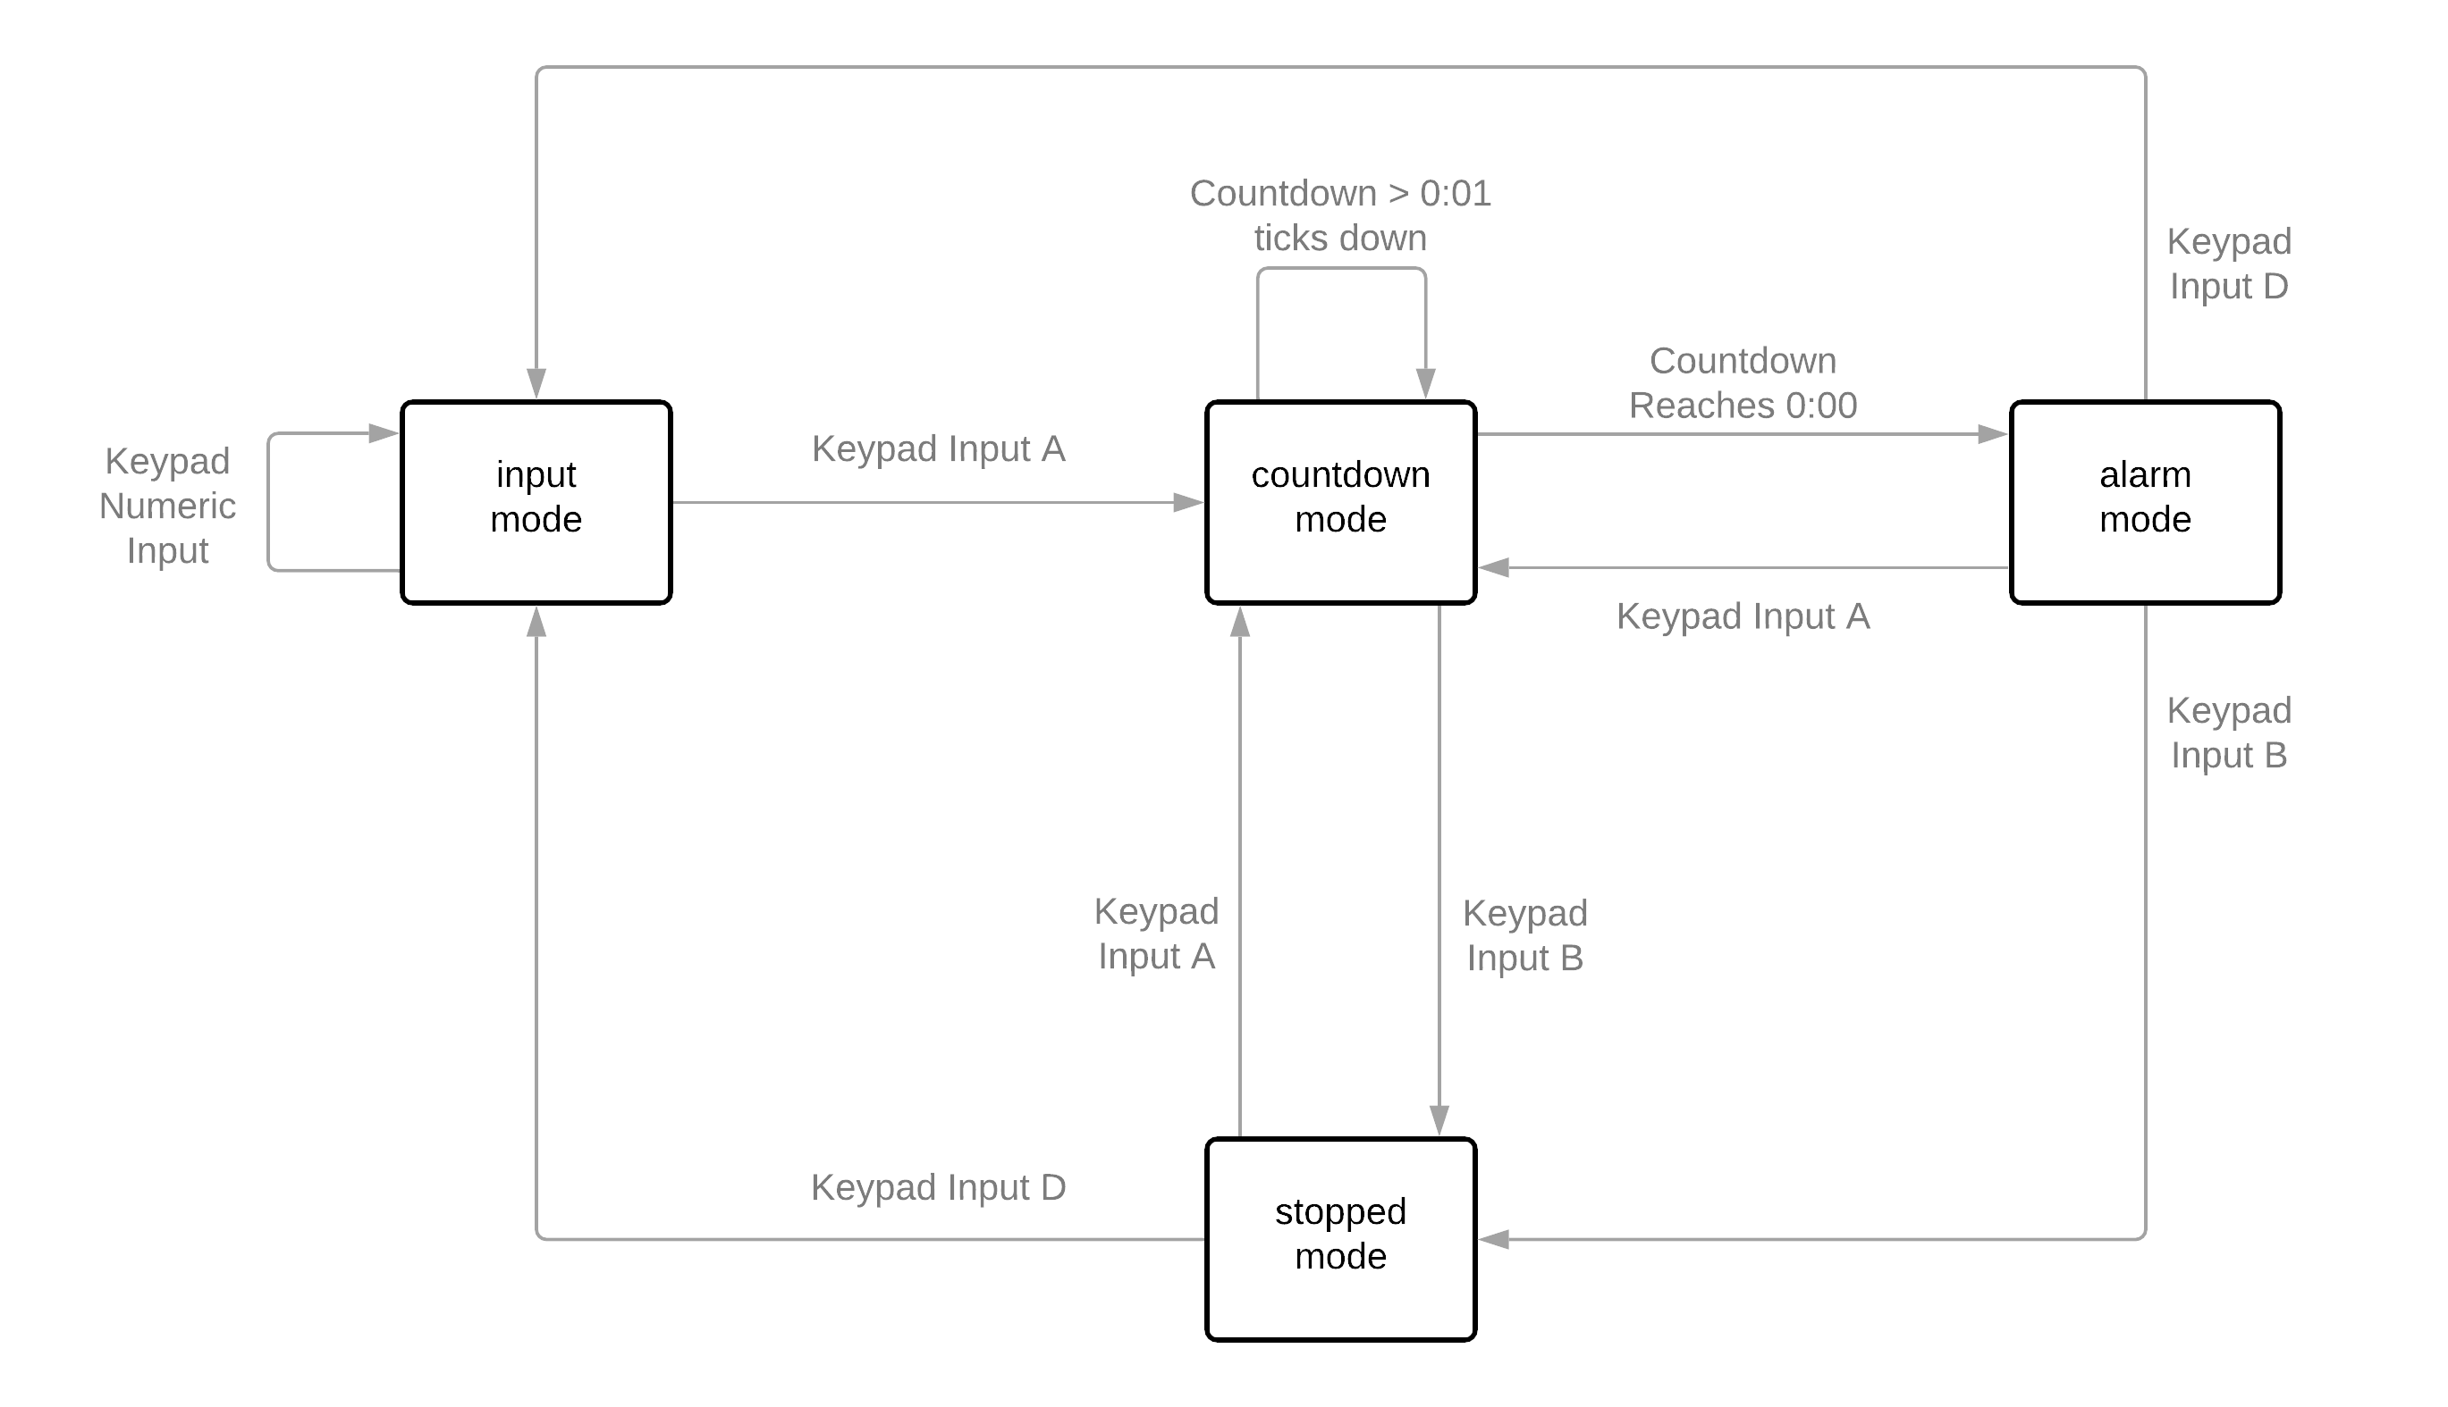

Internal variable notes:

* The countdown start value will be preserved between consecutive uses in the alarm in which the system does not lose power and does not switch to the input mode.
* The countdown start value can be set by switching to the input mode (Keypad Input D).
* The active countdown value will be overwritten to equal the countdown start value every time the system switches to countdown mode (Keyboard Input A).